Name: Vaishnavi Jeevan Shirke
Rollno: MCA2504097

Docker - Container Management

Lab 2 : Docker Container Lifecycle and Management Using Nginx

Step 1: Check Docker Installation
docker –version

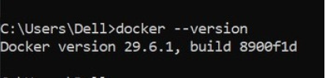

What is happening?
When you type:
docker --version
Docker checks whether the Docker CLI (Command Line Interface) is installed on your computer.
You
│
│ docker --version
▼
Docker CLI
│
▼
Displays Version
Example Output
Docker version 28.2.2, build 123456. This command does not contact Docker Hub or create anything. It simply checks the Docker program installed on your machine.

Step 2: Search for Nginx
docker search nginx

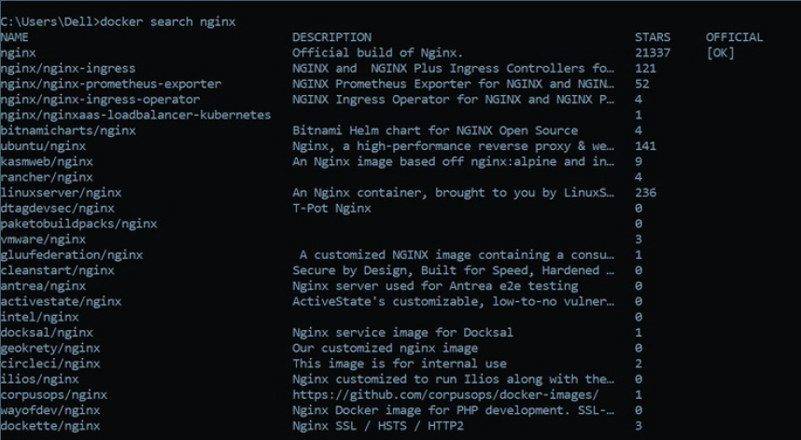

What happens?
Docker connects to Docker Hub, which is the official online repository for Docker images.
Your Computer
│
│ Search "nginx"
▼
Docker Hub
│
▼
Returns Matching Images
Example Output
NAME DESCRIPTION
nginx Official build of Nginx
nginxinc/nginx
bitnami/nginx

Why?
Docker images are stored online. Before downloading one, you can search for available images.
Think of Docker Hub like the Google Play Store or Apple App Store, but instead of apps, it stores Docker images.

Step 3: Download Nginx
docker pull nginx
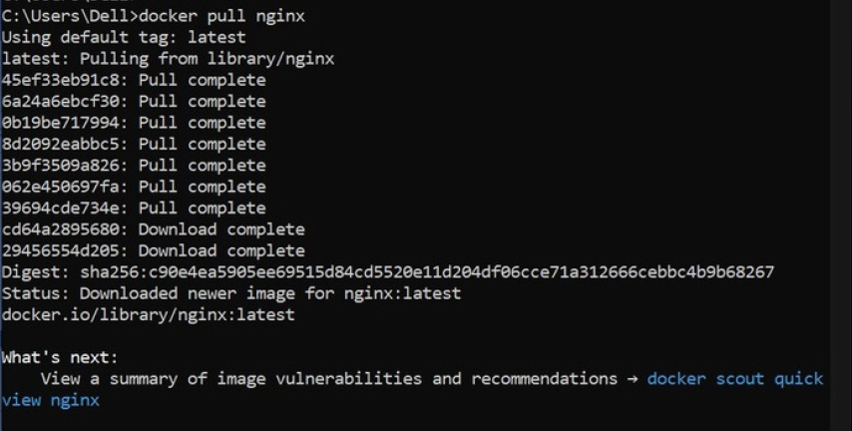

What happens?
Docker downloads the Nginx image from Docker Hub to your computer.
Docker Hub
│
│ Download Image
▼
Your Computer
│
▼
Stored in Docker Images
After downloading:
docker images
shows
REPOSITORY TAG
nginx latest

Important
At this point:
❌ No container exists.
Only the image exists.
Think of it like:
Image = Software Installer

Container = Installed & Running Software

Step 4: View Images
docker images

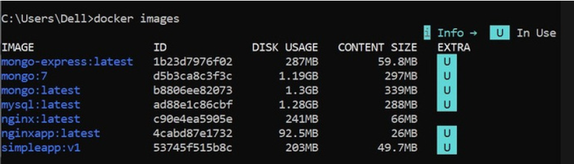

What happens?
Docker shows all downloaded images.
Example
IMAGE ID
nginx
ubuntu
mysql
Nothing is running yet.
You only have installers.

Step 5: Run Nginx
docker run nginx
This is one of the most important Docker commands.
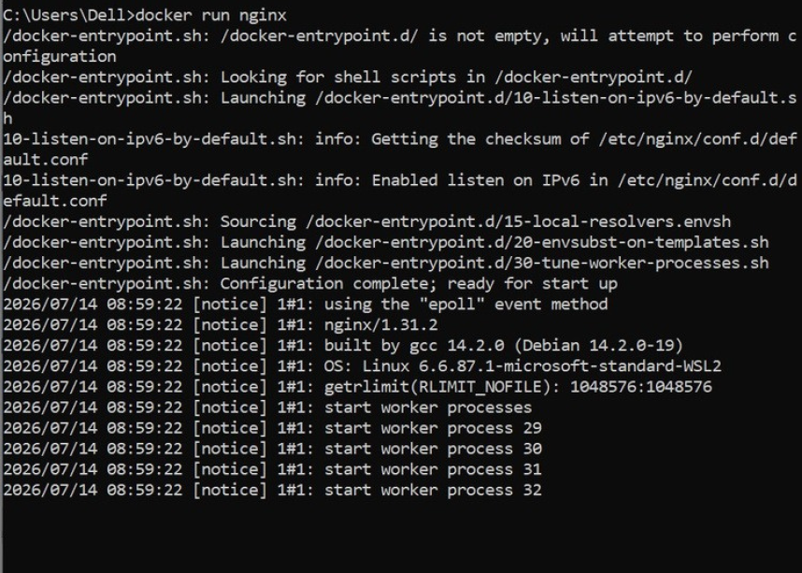

What happens internally?
Docker performs several actions:

Step A
Checks whether the image exists.
Is nginx image available?

YES
If not:
Docker automatically performs:
docker pull nginx

Step B
Creates a new container from the image.
Image

↓

New Container
The image remains unchanged.
Containers are copies of the image.

Step C
Starts the Nginx server.
Container

↓

Nginx Starts
Now Nginx is running inside the container.

Step D
Your terminal becomes attached to the running container.
Terminal

↓

Container Output
Stopping the program using
Ctrl + C
stops the container.

Step 6: Detached Mode
docker run -d nginx
What changed?
-d
means
Detached Mode
Instead of connecting your terminal to the container:
Terminal

↓

Gets Prompt Back
The container continues running in the background.
Docker returns
9f3ab2c89c8d...
This is the Container ID.

Step 7: Name the Container
docker run -d --name mynginx nginx
Without a name:
Docker generates random names.
Example
adoring_pike

crazy_turing

happy_einstein
Using
--name mynginx
makes management easier.
Instead of
docker stop 98ab123...
you simply type
docker stop mynginx

Step 8: Publish a Port
docker run -d --name webserver -p 8080:80 nginx
This is the most important networking concept.

Inside the container
Nginx always listens on
Port 80
Container

Nginx

↓

80
But your computer cannot automatically access that internal port.
So Docker creates a mapping.
Computer

8080

↓

Container

80
Meaning
localhost:8080

↓

Container Port 80
Opening
http://localhost:8080
actually forwards the request to
Container

↓

Nginx

↓

Port 80

Step 9: List Running Containers
docker ps
Shows
Container ID

Image

Status

Ports

Name
Example
mynginx

Up 5 minutes

0.0.0.0:8080->80
Meaning
Host Port

8080

↓

Container Port

80

Step 10: Stop Container
docker stop mynginx
Docker sends a signal to Nginx.
Please Stop Gracefully
Nginx saves its state and exits cleanly.
Container Status
Running

↓

Exited
Notice:
The container is not deleted.
It is only stopped.

Step 11: Start Container Again
docker start mynginx
Docker does not create a new container.
It simply starts the existing one.
Stopped Container

↓

Running Container

Step 12: Restart
docker restart mynginx
Equivalent to
docker stop mynginx

docker start mynginx

Step 13: View Logs
docker logs mynginx
Every application writes messages.
Example
Nginx Started

Request Received

Response Sent
Docker stores these logs.
Useful for debugging.

Step 14: Enter the Container
docker exec -it mynginx bash
This command opens a shell inside the running container.
Your Computer

↓

Docker

↓

Container

↓

Linux Bash
Now commands like
pwd
ls
cd /usr/share/nginx/html
are executed inside the container, not on your Windows machine.
This is very useful for troubleshooting or inspecting files.

Step 15: Remove the Container
docker rm mynginx
Docker deletes the container only.
Container

❌ Deleted
The image is still available.
You can create a new container anytime using:
docker run nginx

Step 16: Remove the Image
docker rmi nginx
Now Docker removes the downloaded image from your local system.
Image

❌ Deleted
If any container still depends on that image, Docker will refuse to remove it until those containers are deleted.

